PRACTICAL NO. 1: FREQUENCY AND CHARTS

- Recode the variable ‘value of the house’ as 1-100-150, 2-150-200 and so on. Compute the frequency table for age group, education, religion and number of years in the company.

Solution:
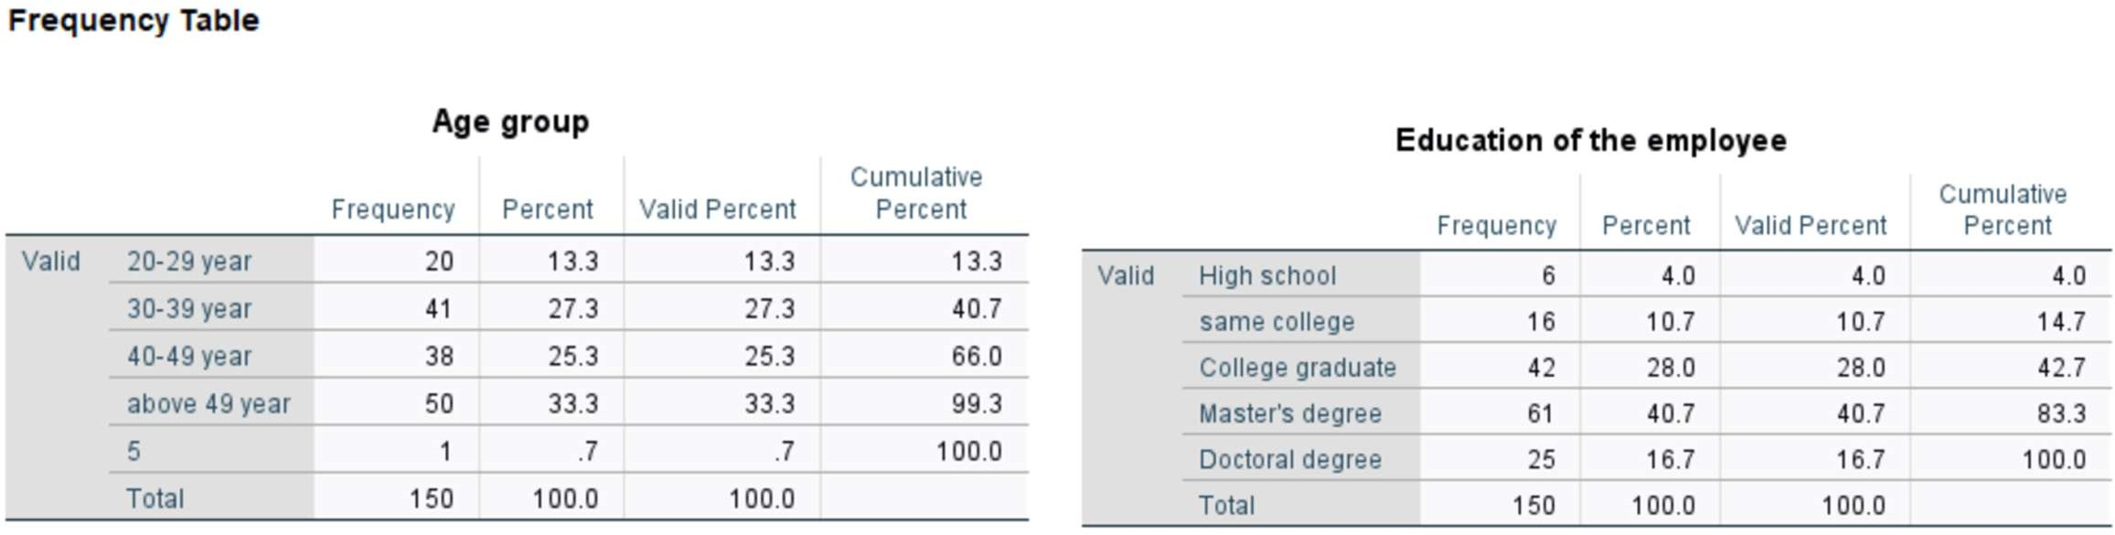

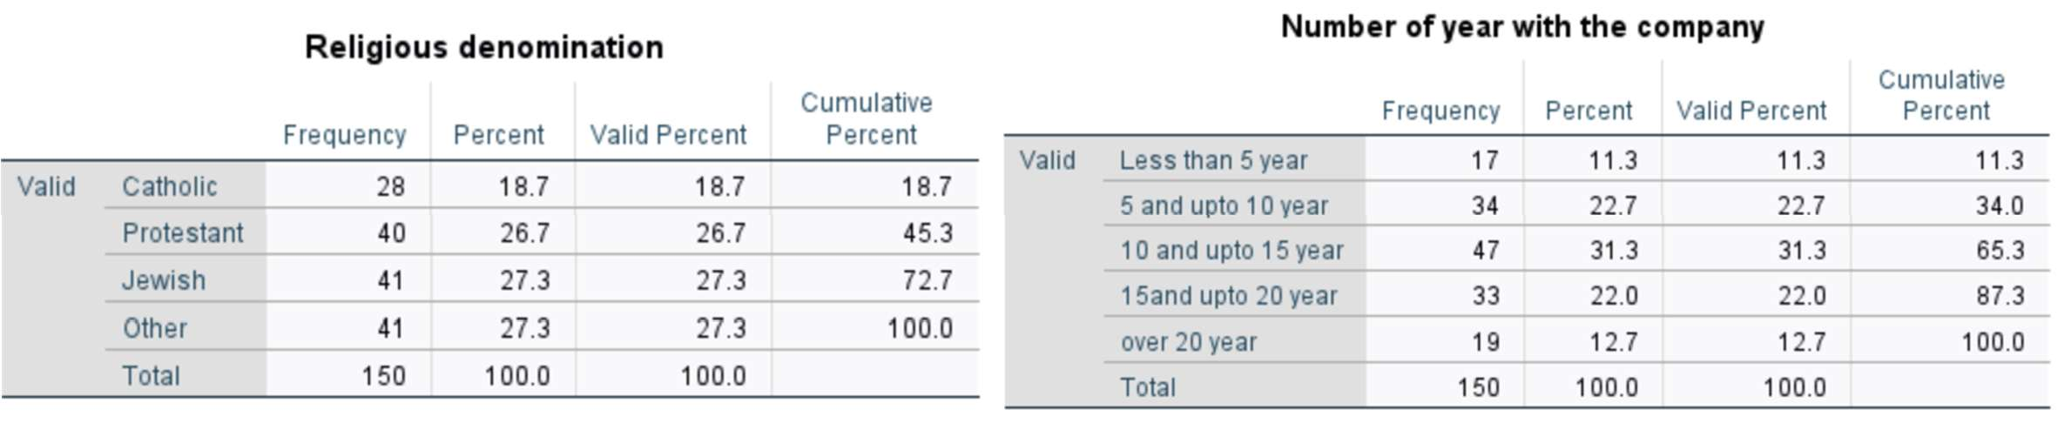
Interpretation:
Age Group: Most of the employees are older, with the largest group being "above 49 years old" (33.3%). Younger employees are rare (only 13.3% are under 30).
Education: The employees are highly educated. Most people have a Master's degree (40.7%) while few people stopped after high school (only 4%).
Religion: The company has a diverse religious mix. Protestants, Jewish employees, and those from “Other” religions each make up about 27%. Catholics are slightly fewer, at 18.7%.
Years in the Company: Tenure leans toward medium-to-long service. The largest group (31.3%) has been with the company for 10–15 years. There are more long-term employees (over 20 years) than newcomers (under 5 years).

- Construct the histogram for age group, education and religion and number of years in the company.

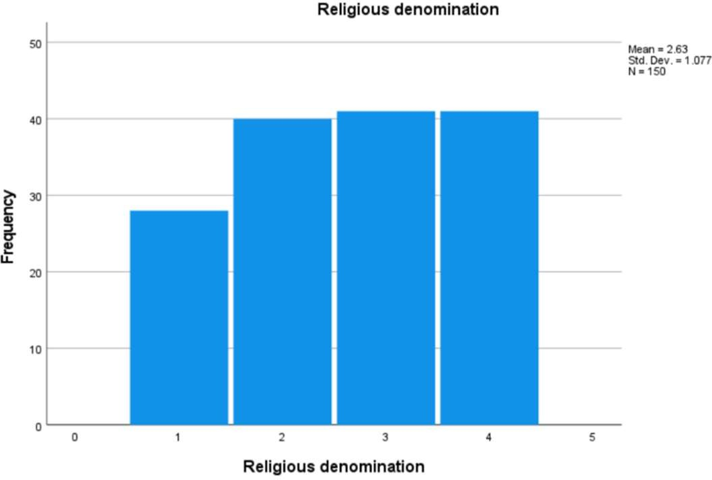
Solution:
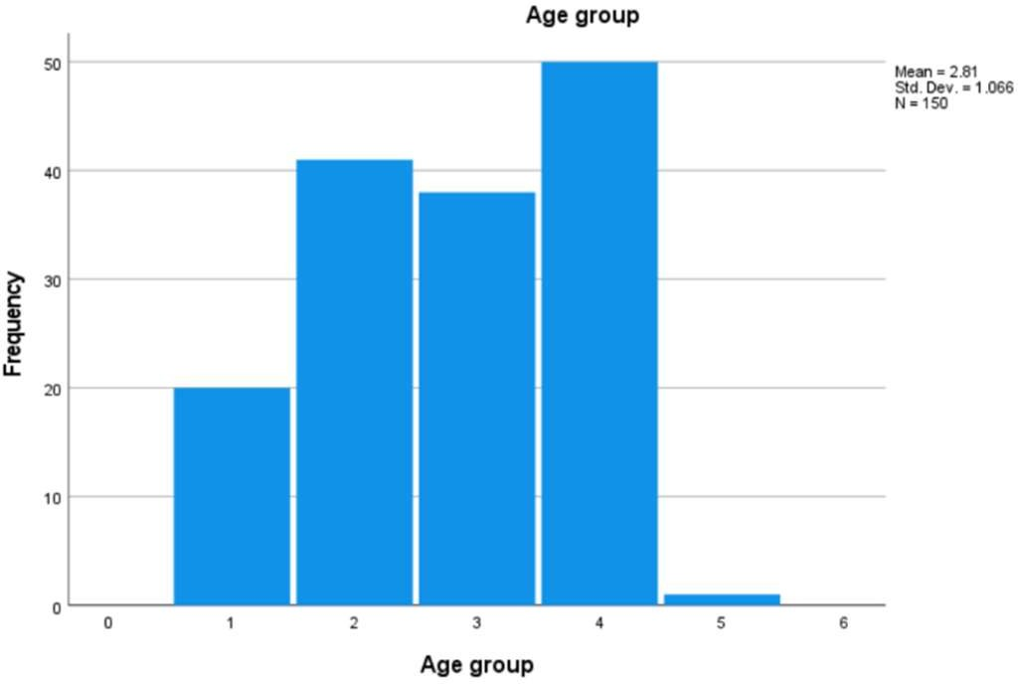
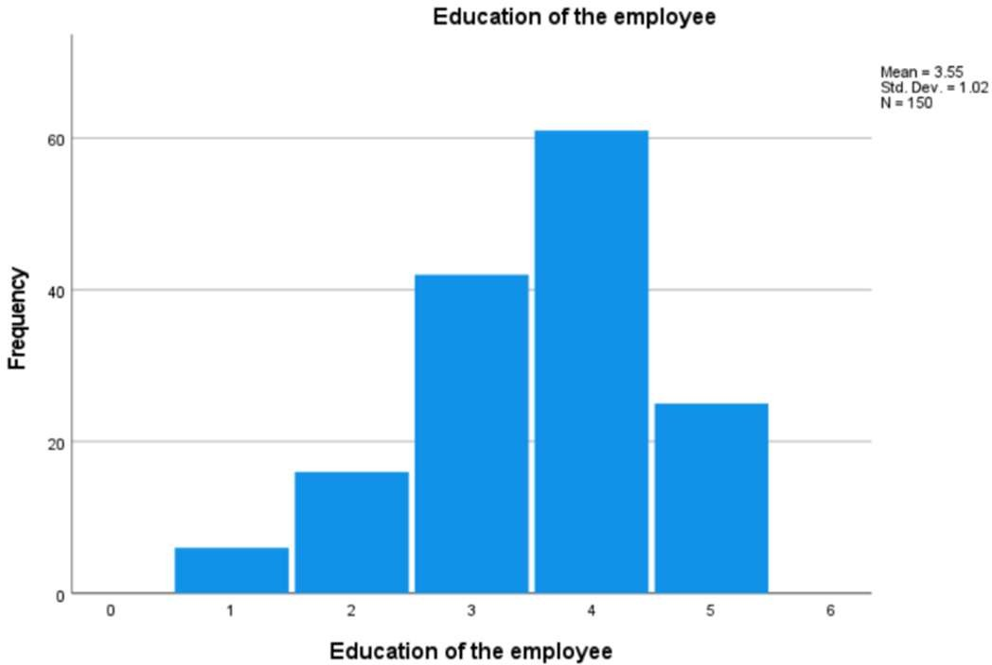
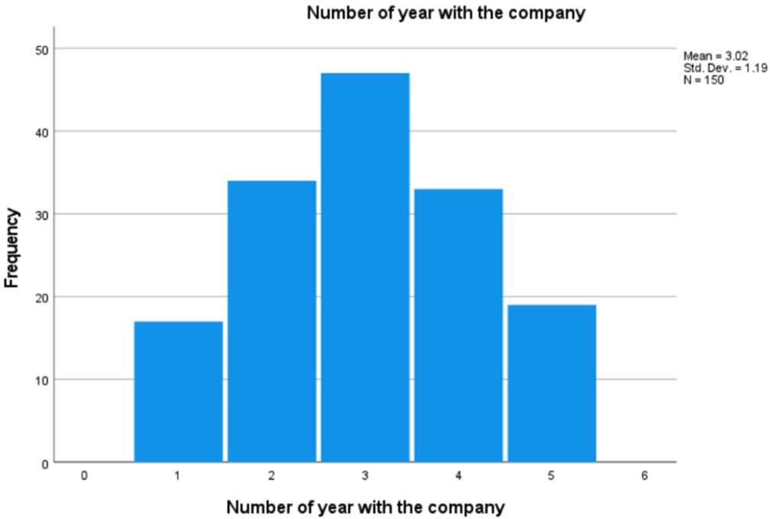

Interpretation:
Age Group (Mean = 2.81, SD = 1.07): The average age group falls between 30-39 and 40-49 years. The standard deviation shows moderate spread, meaning employees are distributed across all age ranges.
Religious Denomination (Mean = 2.63, SD = 1.08): The mean has no real meaning since religion is categorical. The histogram simply shows the four groups have nearly equal frequencies.
Education (Mean = 3.55, SD = 1.02): The average education level is between College Graduate and Master's degree. The low standard deviation indicates most employees cluster around this high education level.
Number of Years in Company (Mean = 3.02, SD = 1.19): The average tenure falls near the 10-15 year category. The slightly higher standard deviation shows more variability in tenure compared to other variables.

- Show steam and leaf display for salary, value of the house, Distance in miles from house to work, Sick days taken during the previous year.

Solution:
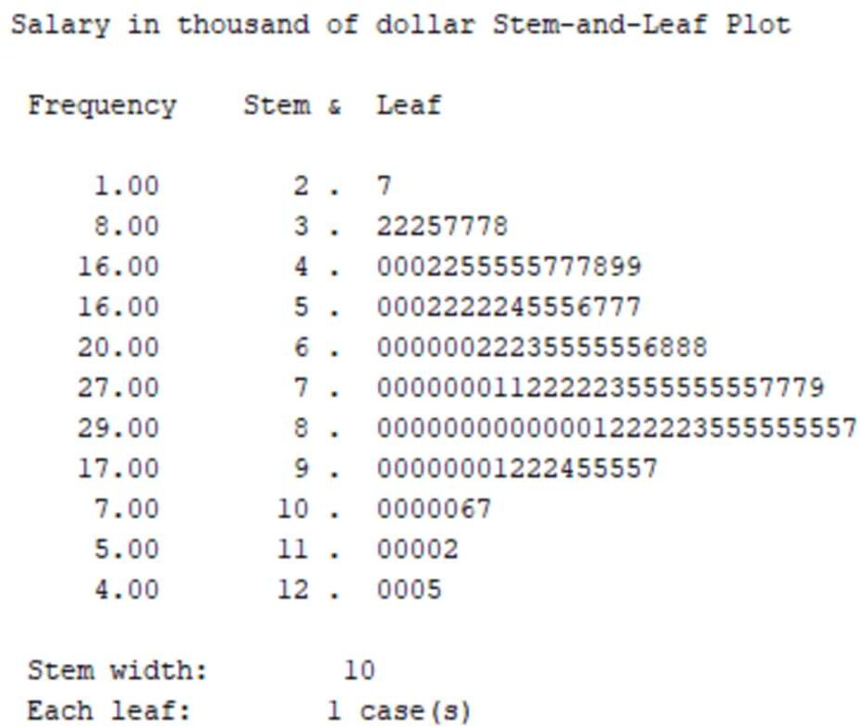
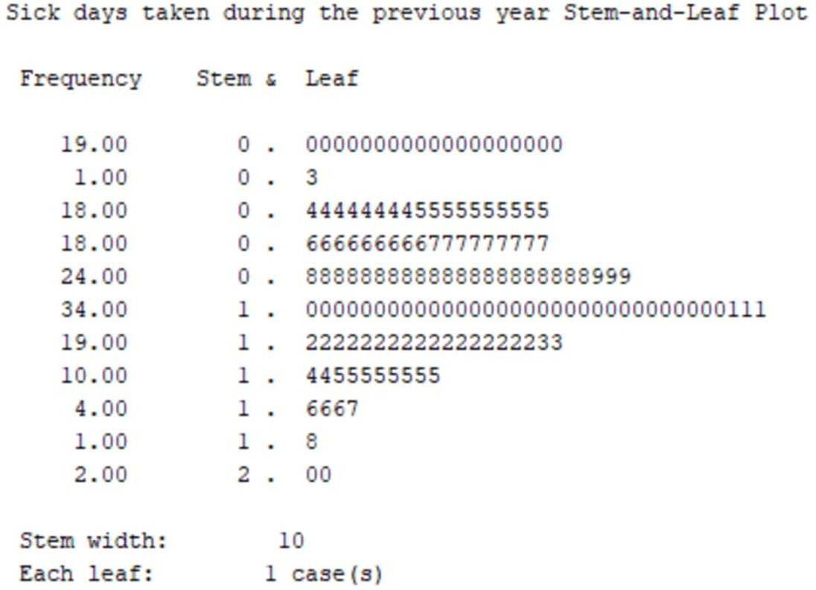
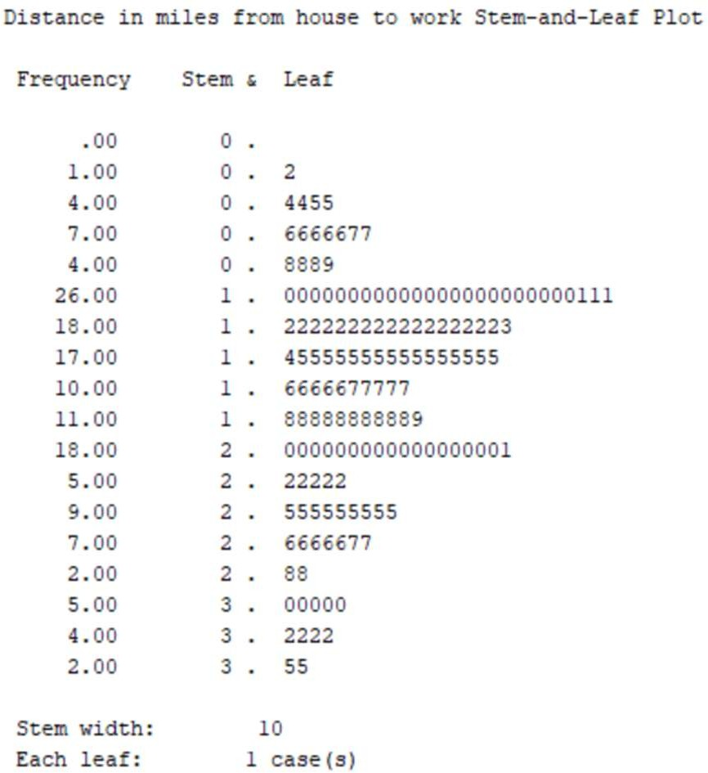
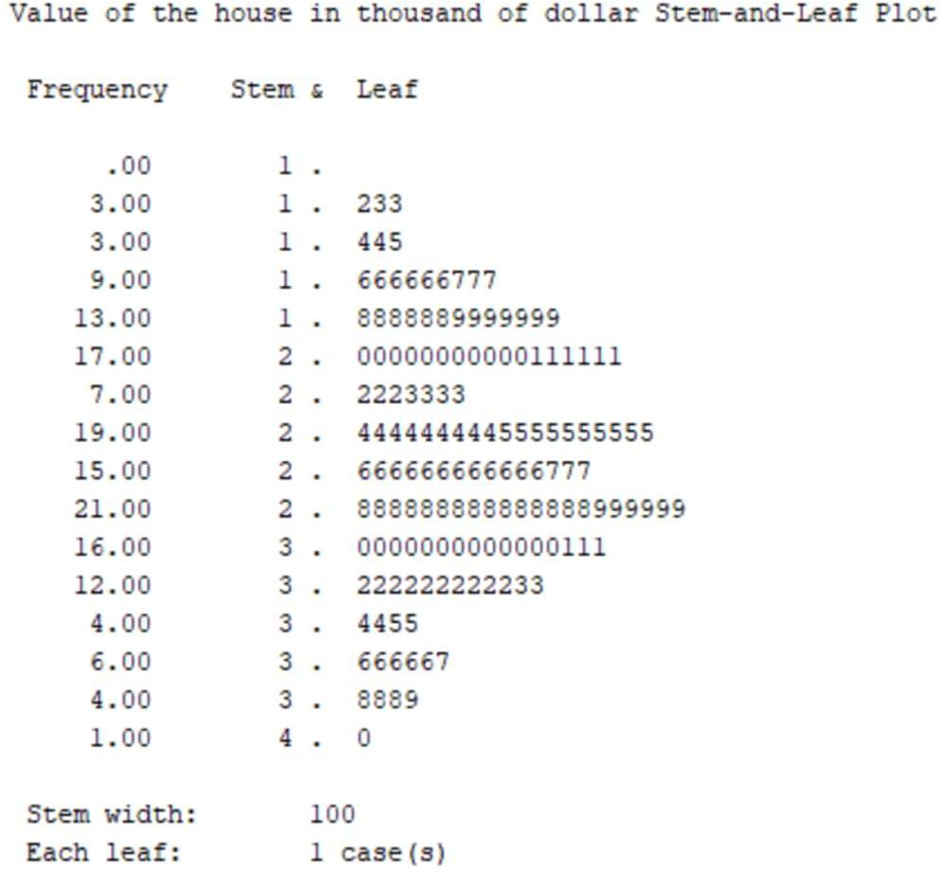

Interpretation:
Salary: Positively skewed (tail extends toward higher values)
Sick Days: Positively skewed (concentration on lower end, tail toward upper end) Distance: Approximately symmetric (values evenly distributed around center) House Value: Approximately symmetric (balanced distribution around midpoint)

PRACTICAL NO. 2: DESCRIPTIVE STATISTICS
  - Draw descriptive statistics of all employee, Male employee, female employee for the salary, value of the house, Distance in miles from house to work, Sick days taken during the previous year.

Solution:
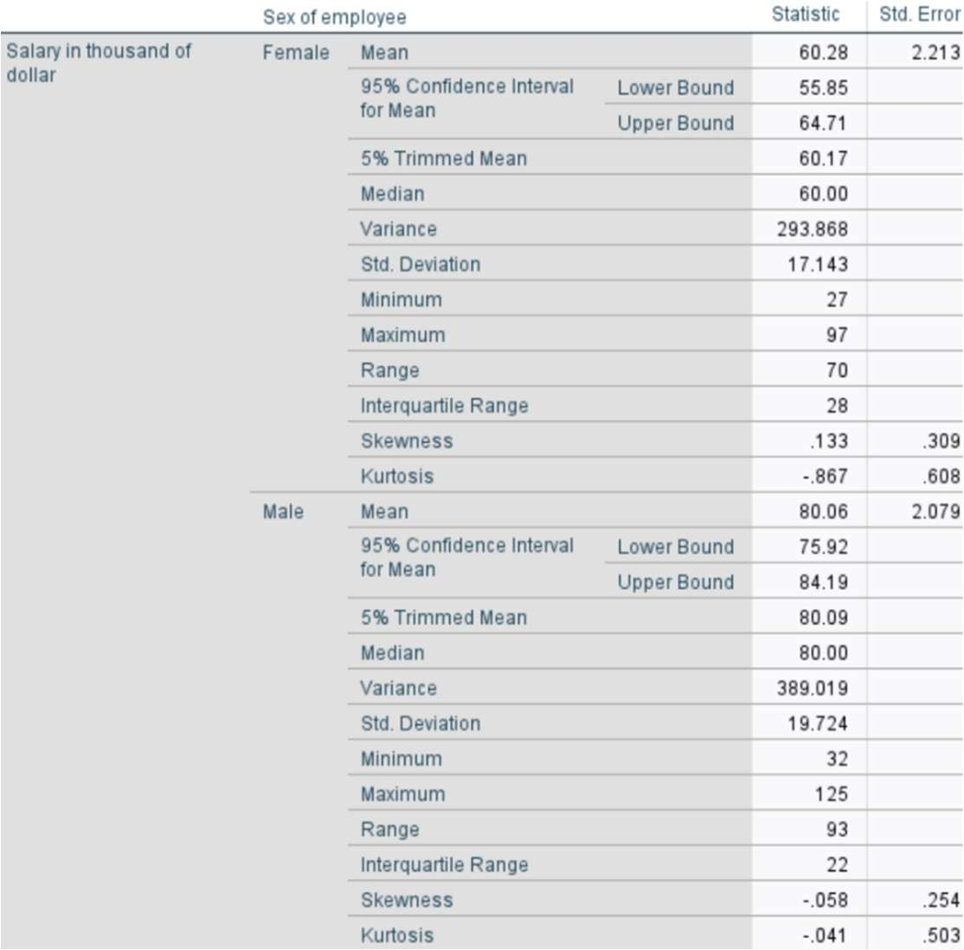
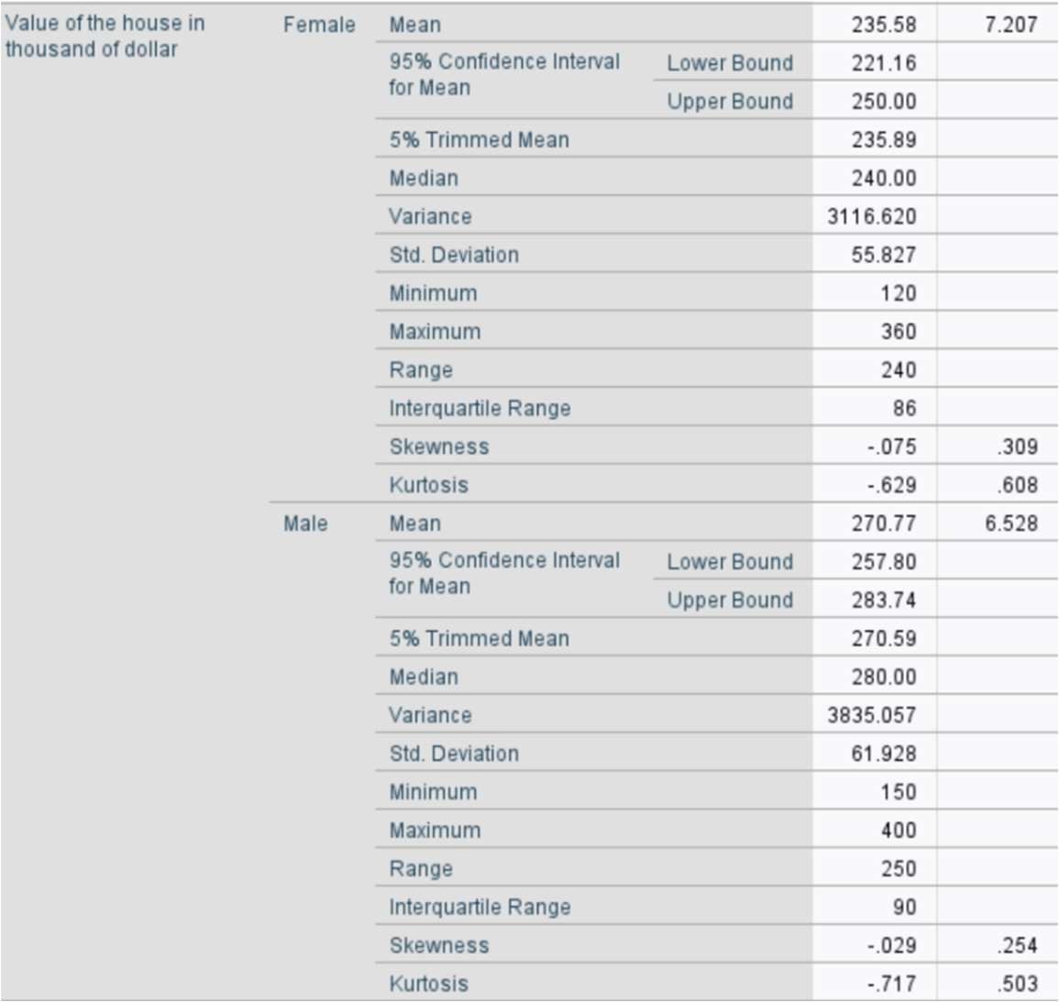
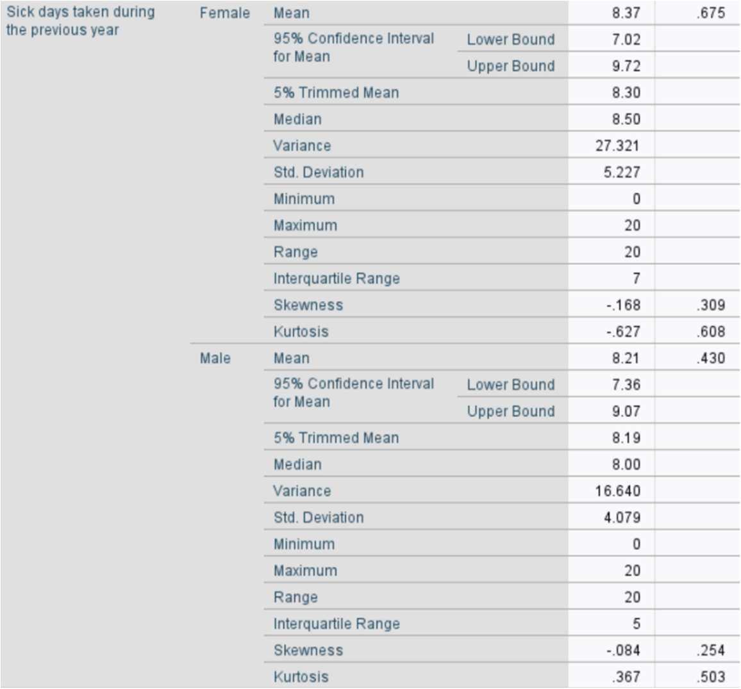
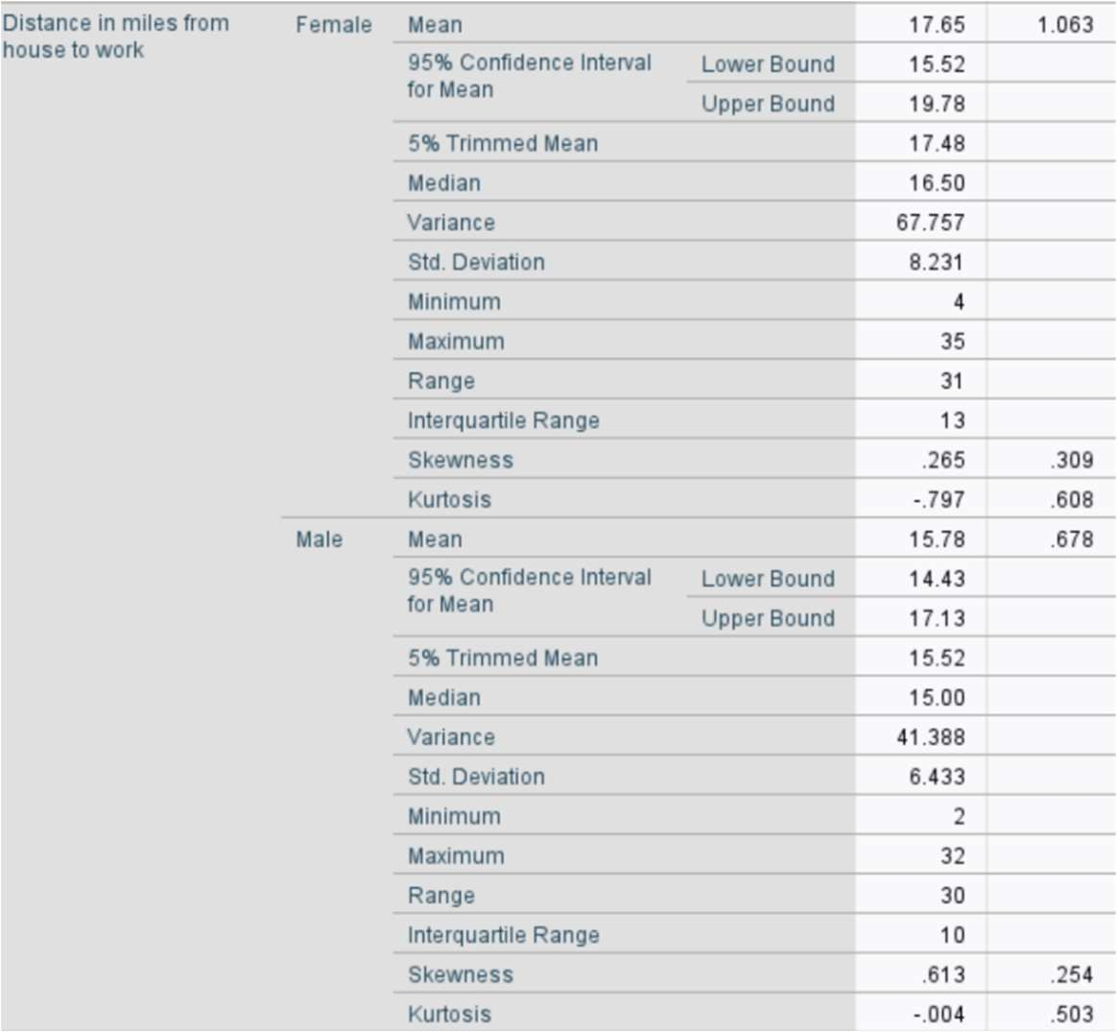

Interpretation:
Males have higher average salary (80.06k vs 60.28k) and house value (270.77k vs 235.58k) than females. Females take slightly more sick days (8.37 vs 8.21) and travel farther to work (17.65 vs 15.78 miles). Males show greater variability in salary and house value, while females show more variability in sick days and distance. All distributions are approximately symmetric.

  - The coefficient of variation of the salaries for male and female and find whose salary is most uniformly distributed.

Solution:

Formula:
Std. Deviation
𝐶𝑉 = ( Mean ) × 100

For Female:
    - Mean = 60.28
    - Std. Deviation = 17.143

17.143

𝐶𝑉_{Female} = ( 60.28 ) × 100 = 28.44%

For Male:
    - Mean = 80.06
    - Std. Deviation = 19.724
19.724
𝐶𝑉_{Male} = ( 80.06 ) × 100 = 24.64%

Conclusion:
    - Male CV = 24.64%
    - Female CV = 28.44%
Since lower CV indicates more uniformity (less relative variability), male salaries are more uniformly distributed than female salaries.

  - Box plot for salary, value of the house, distance in miles from house to work, Sick days taken during the previous year.
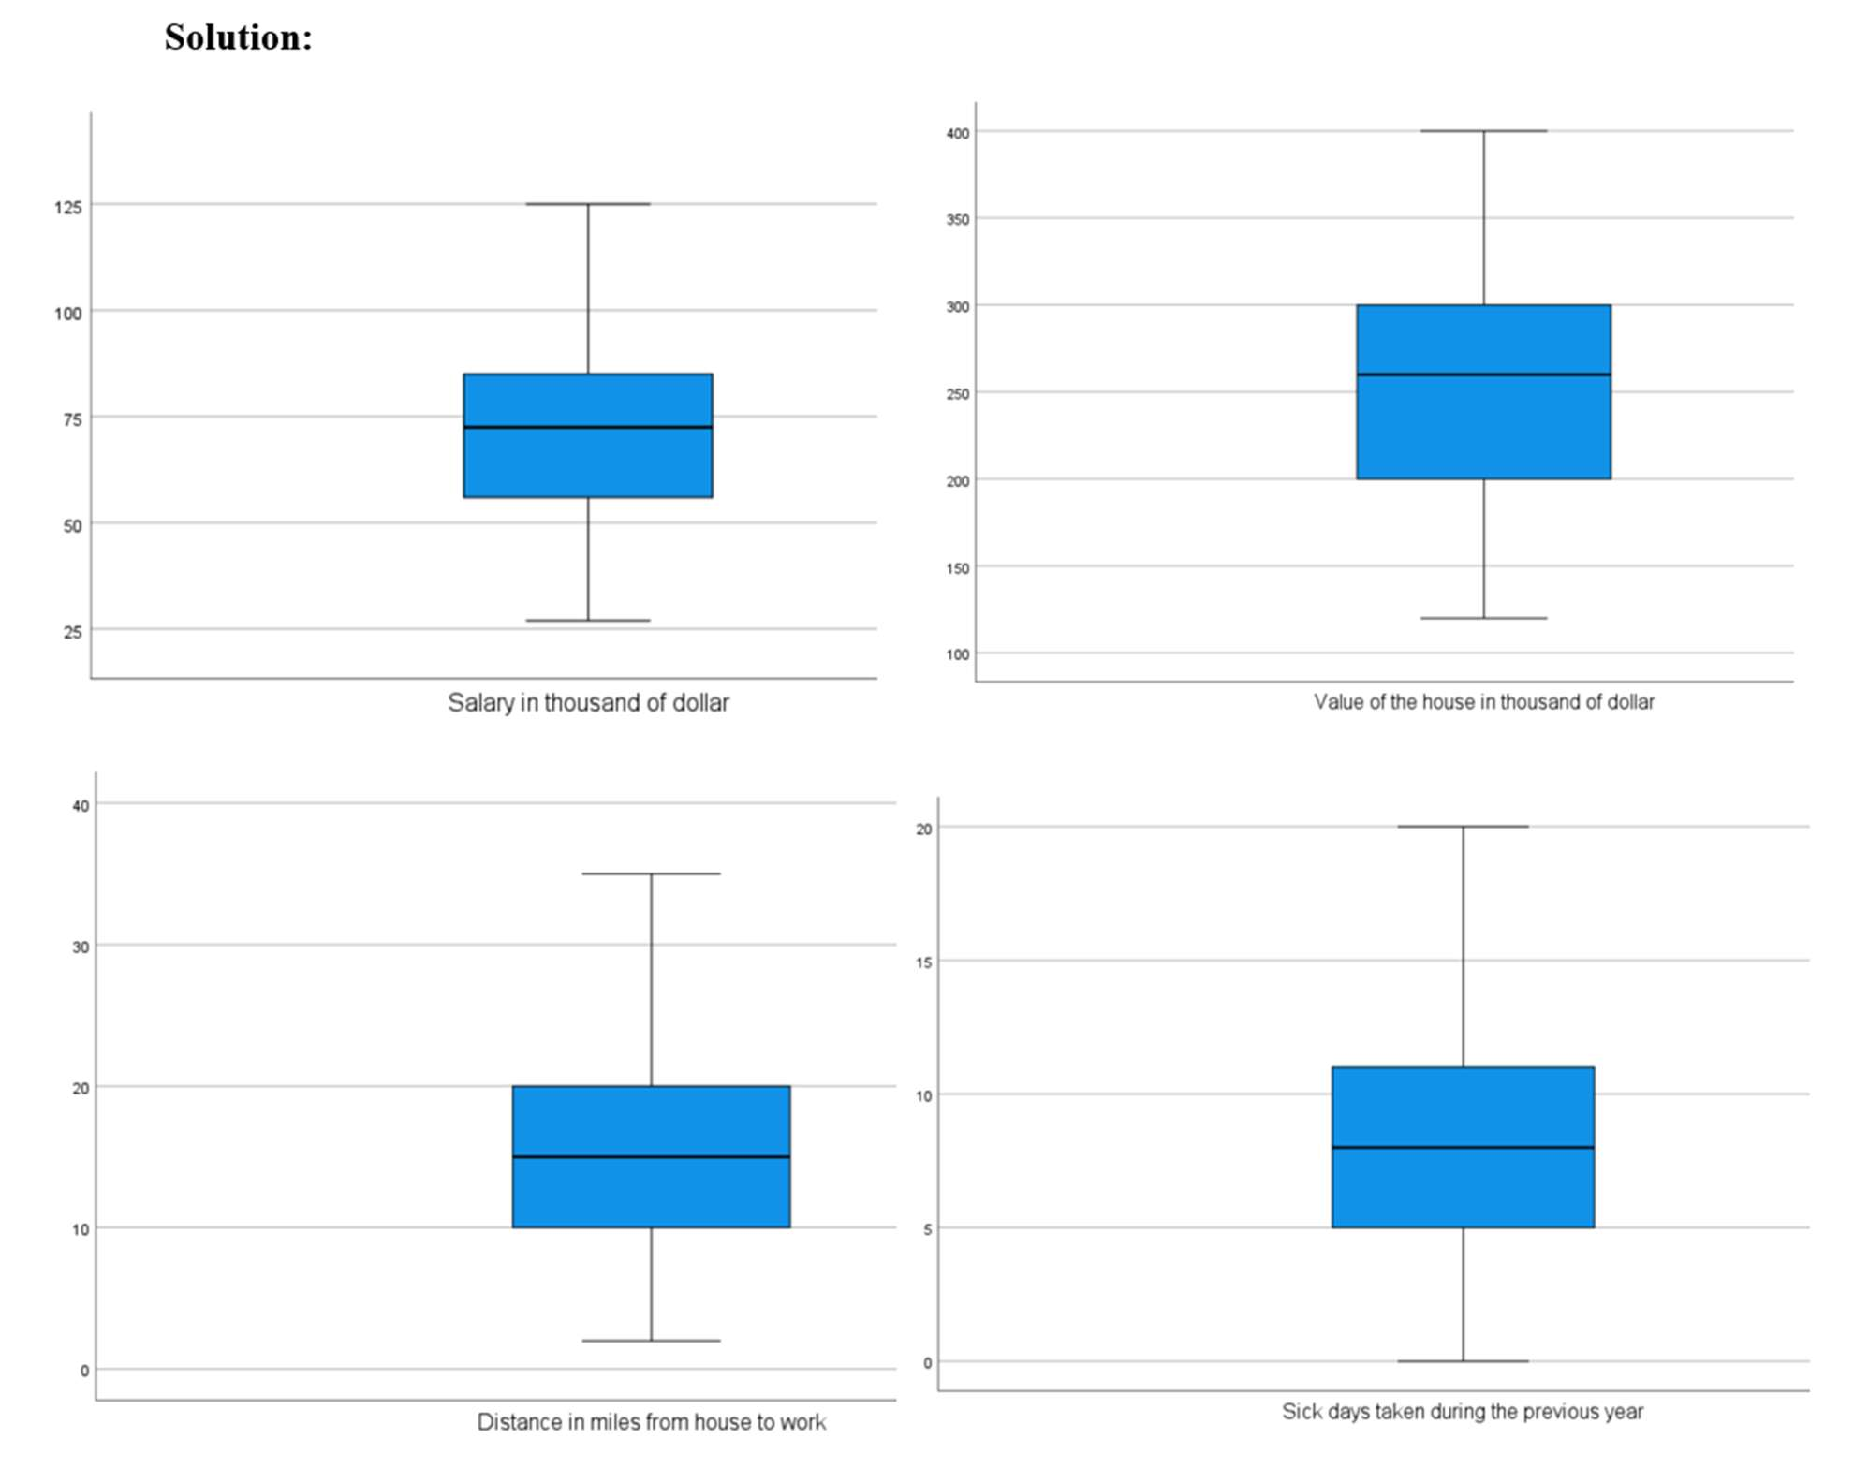

Interpretation:
    - Salary: The distribution appears slightly positively skewed (right-skewed) since the upper whisker is longer and values extend further above the median.
    - House Value: The distribution is positively skewed, indicating a few houses with much higher values than the majority.
    - Distance to Work: The distribution is positively skewed, showing that while most people commute moderate distances, a few travel much longer distances.
    - Sick Days: The distribution is slightly positively skewed, meaning most employees take relatively fewer sick days, with a few taking significantly more

PRACTICAL NO. 3: TEST OF HYPOTHESIS

One sample test:
  - Test the hypothesis that the average salary of the whole employees of the company is 75 thousand dollars and 50 thousand dollar and interpret.

Solution:
    - H0: µ = 75
    - v/s H1: µ ≠ 75
    - Level of significance: α = 0.05
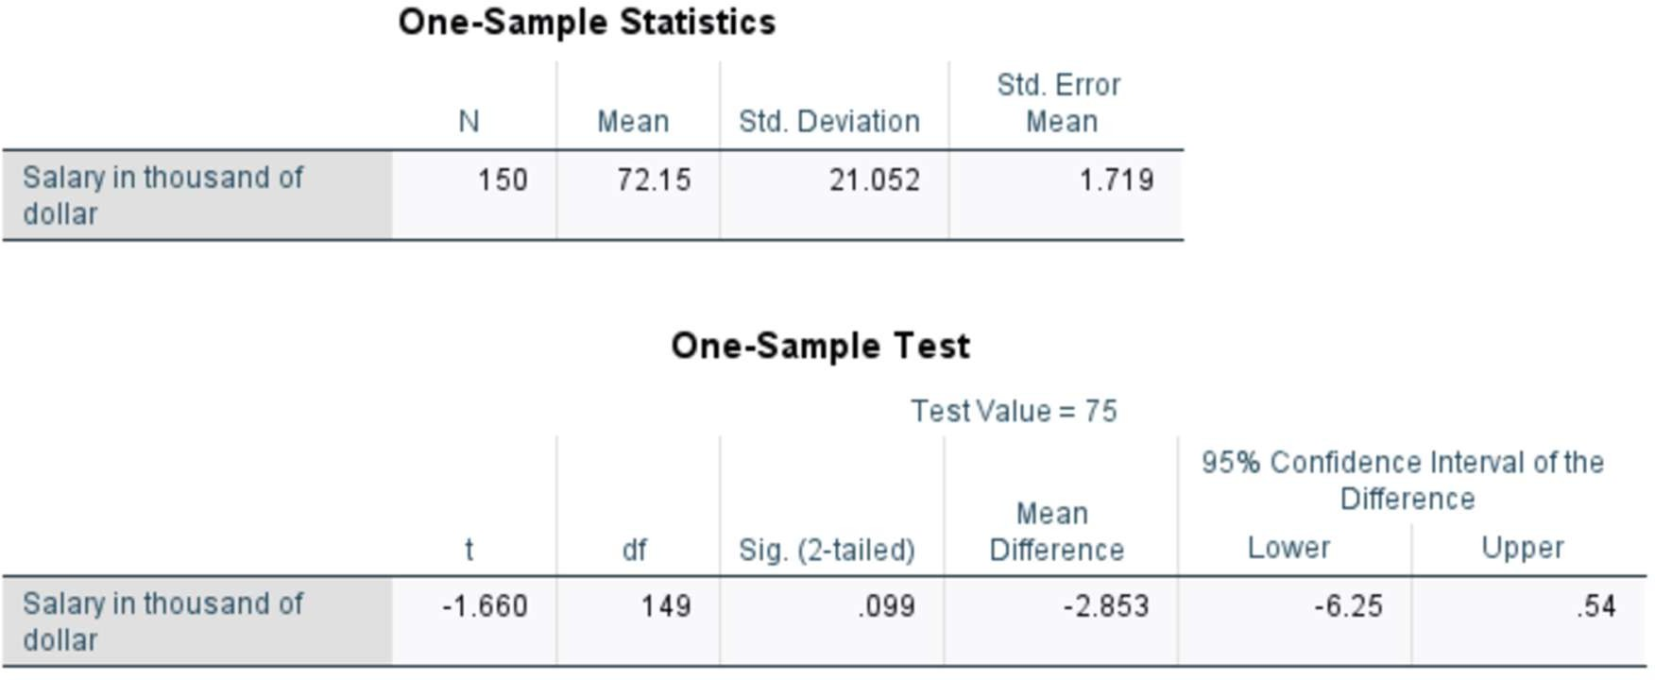
Interpretation: The t value is -1.680. Since p value = 0.999 > 0.05. Hence we do not reject H0. There is strong evidence to say that the average salary does not differ from 75 thousand dollars.

    - H0: µ = 50
    - v/s H1: µ ≠ 50
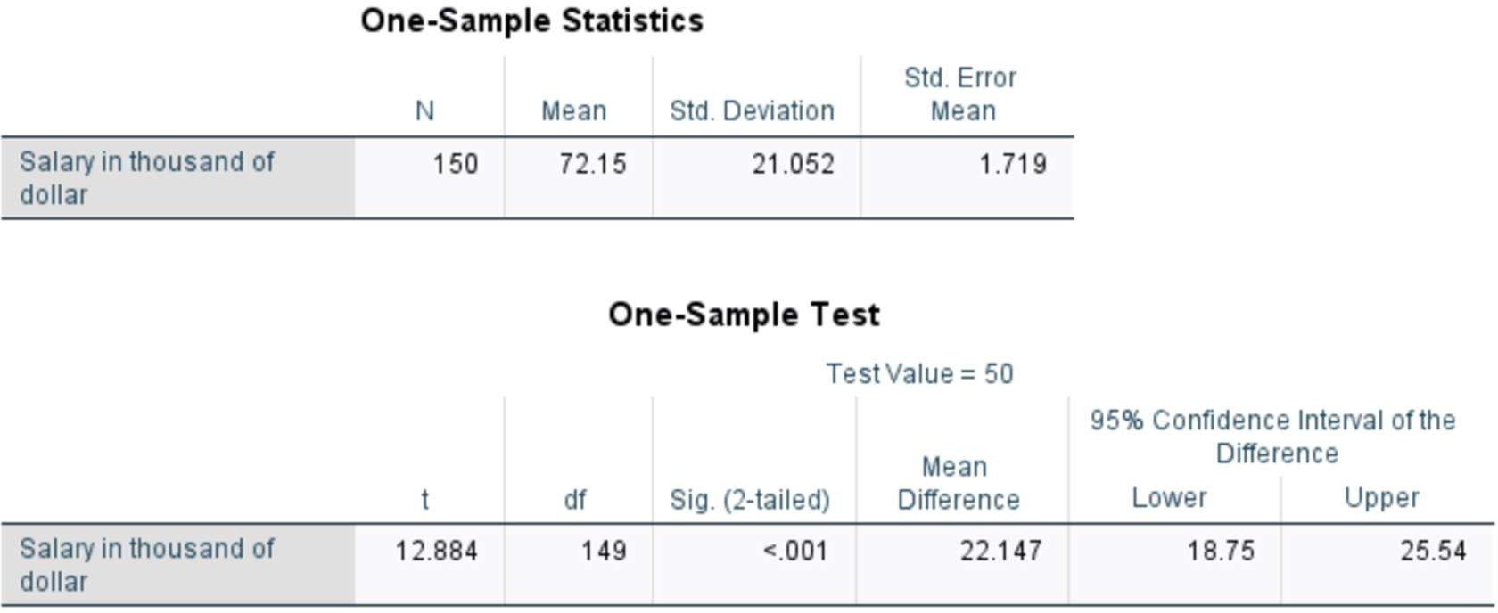
Interpretation: The t value is 12.884. Since p value < 0.001 < 0.05. Hence we reject H0. There is strong evidence to say that the average salary differs from 50 thousand dollars.

  - Test the hypothesis of 10% of the data set 1 that the average salary is 75 thousand dollars and 50 thousand dollar and interpret.

Solution:
    - H0: µ = 75
    - v/s H1: µ ≠ 75
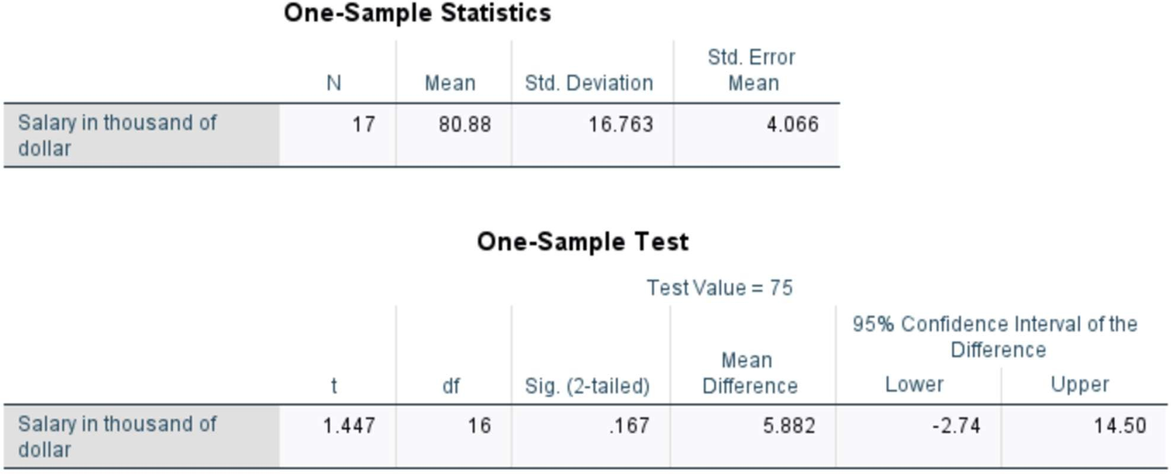
Interpretation: The t value is 1.447. Since p value = 0.167 > 0.05. Hence we do not reject H0. There is strong evidence to say that the average salary does not differ from 75 thousand dollars.

    - H0: µ = 50
    - v/s H1: µ ≠ 50
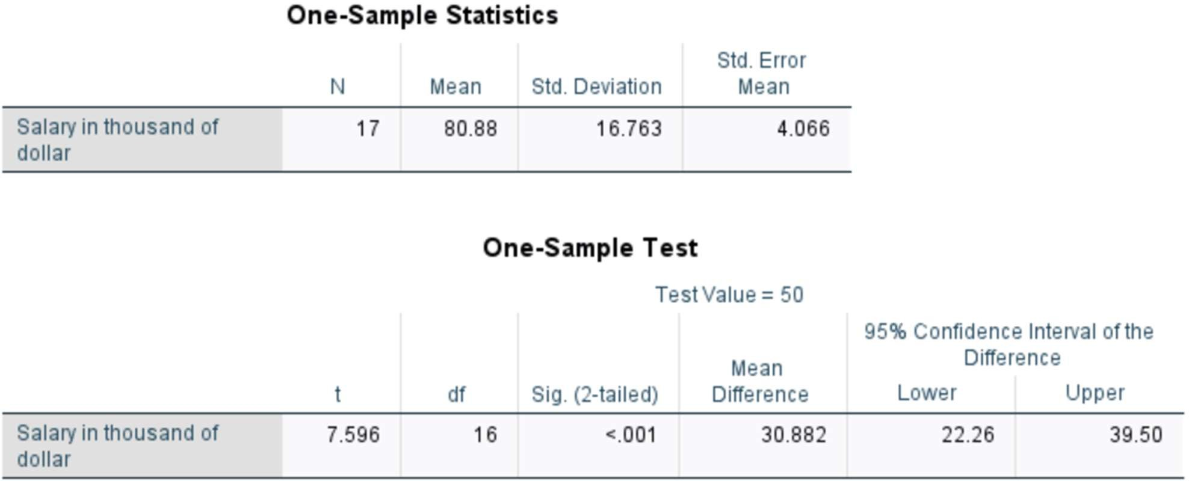
Interpretation: The t value is 7.596. Since p value < 0.001 < 0.05. Hence we reject H0. There is strong evidence to say that the average salary differs from 50 thousand dollars.

  - Test the hypothesis of 10% of the data set 1 that the average value of house is 75 thousand dollars and 50 thousand dollar and interpret.

Solution:
    - H0: µ = 75 v/s H1: µ ≠ 75
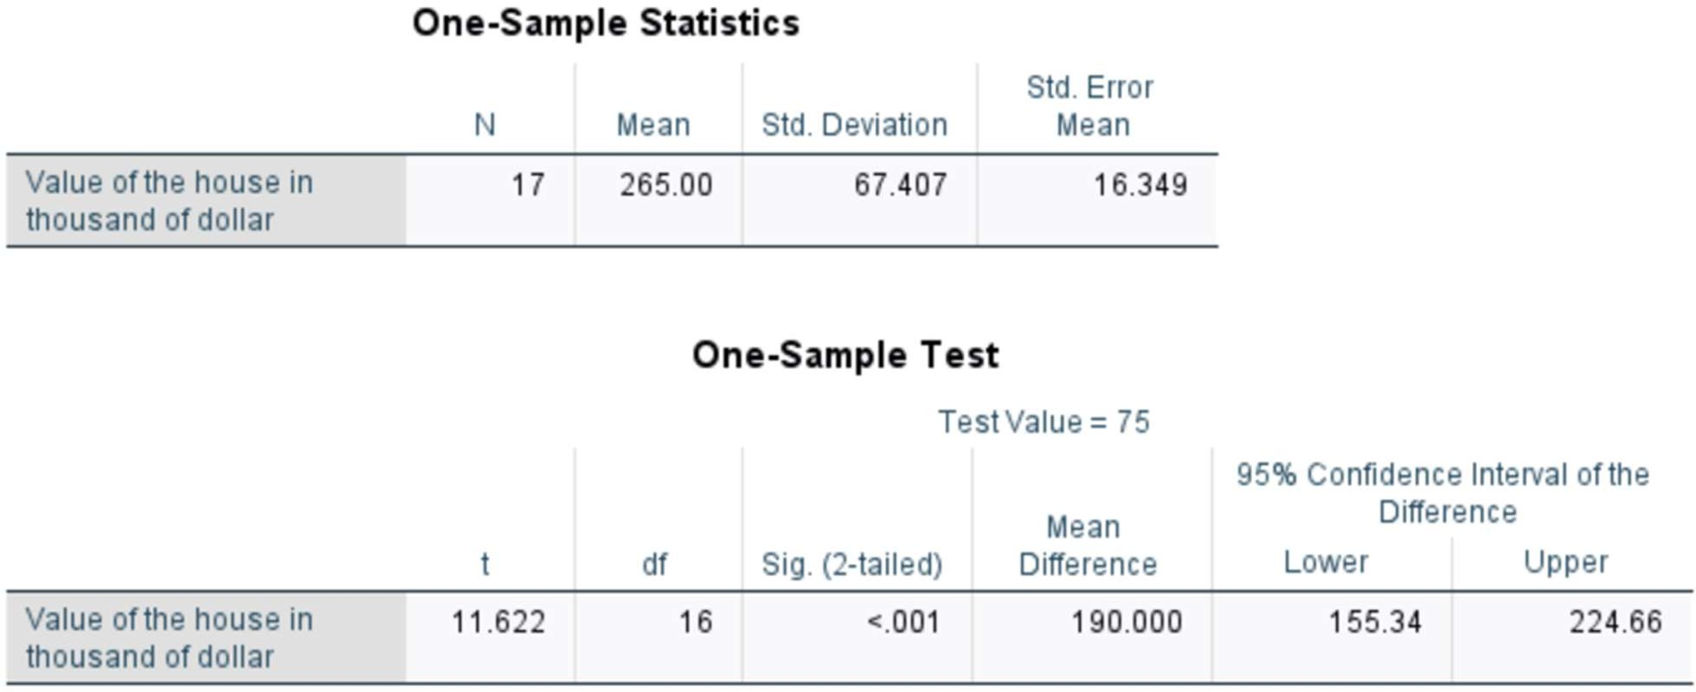
Interpretation: The t value is 11.622. Since p value < 0.001 < 0.05. Hence, we reject H0. There is strong evidence to say that the average house value is not equal to 75 thousand dollars.

    - H0: µ = 50
    - v/s H1: µ ≠ 50
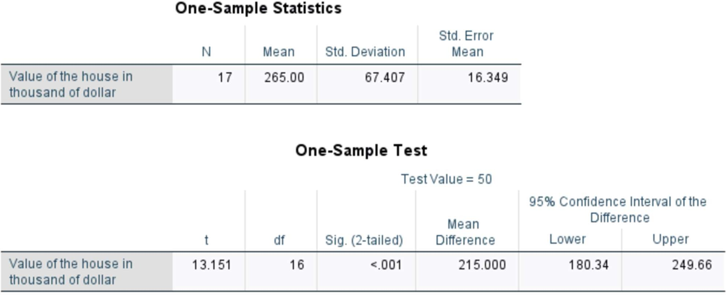

Interpretation: The t value is 13.151. Since p value < 0.001 < 0.05. Hence, we reject H0. There is strong evidence to say that the average salary differs from 50 thousand dollars.

  - At 0.05 level of significance, is their evidence that average number of sick days taken during the previous year were 10 days. (use id 1 to 25 of the data set1)

Solution:
    - H0: µ = 10
    - v/s H1: µ ≠ 10
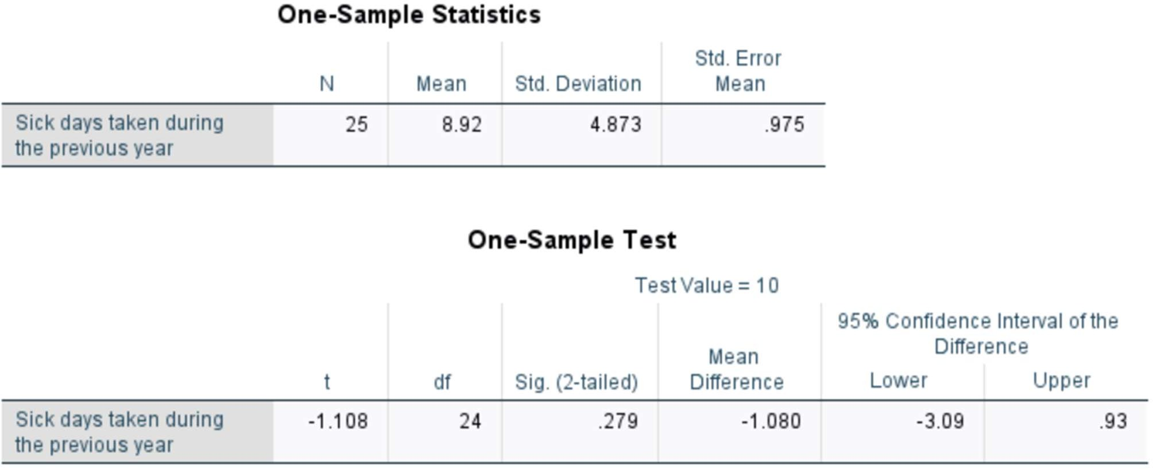
Interpretation: The t value is -1.108. Since p value = 0.279 > 0.05. Hence, we do not reject H0. There is strong evidence to say that the average number of sick days is equal to 10 days.

- Two sample tests:
  - Test the hypothesis that is there any significance difference between mean salary of male and female employees.

Solution:
    - H0: µ1 = µ2
    - v/s H1: µ1 ≠ µ2
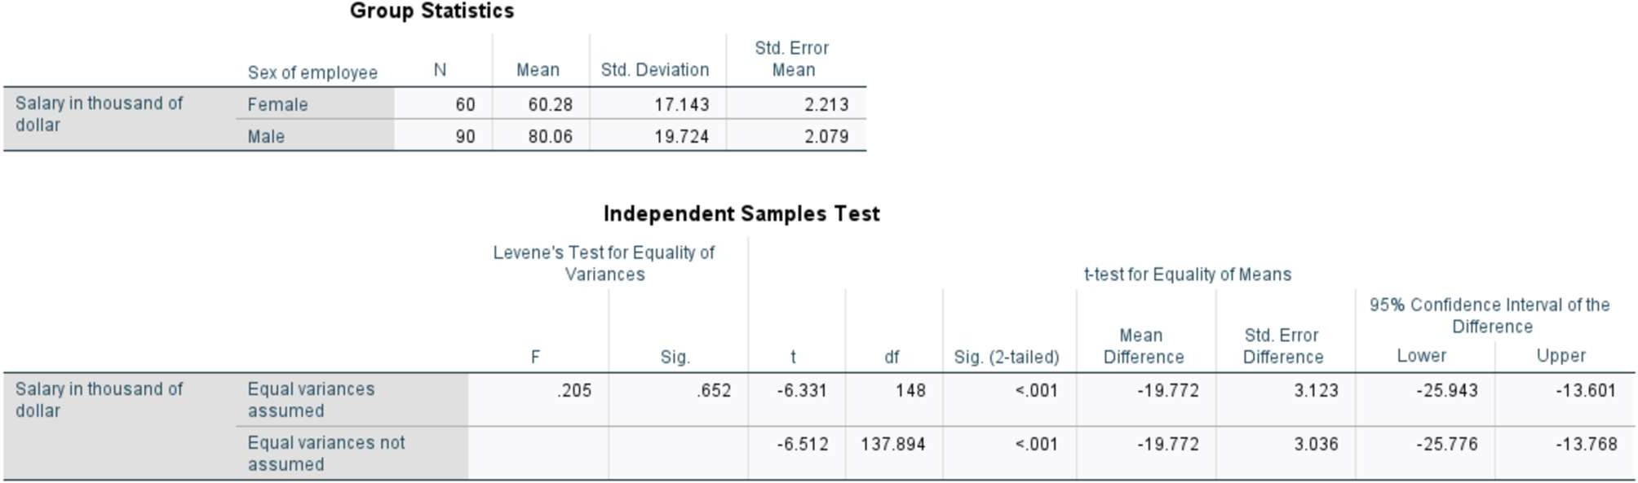

Interpretation: Here t = -6.331, df = 148. Since p-value < 0.001 < 0.05. Hence, we reject H0. There is strong evidence to say that there is significance difference between mean salary of male and female employees.

  - Test the hypothesis that is there any significance difference between mean salary of male and female (use id 25 to 50 of the data set1)
Solution:
- H0: µ1 = µ2
- v/s H1: µ1 ≠ µ2
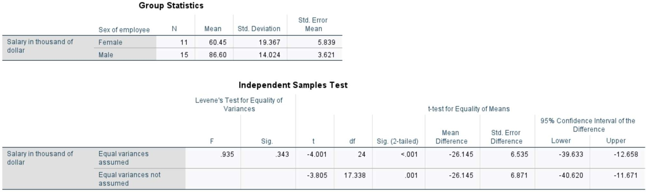
Interpretation: Here t = 4.001, df = 24. Since p-value < 0.001 < 0.05. Hence, we reject H0. There is strong evidence to say that there is significance difference between mean salary of male and female employees.

  - At 0.05 level of significance, is their evidence that average number of sick days taken during the previous year were significance difference between male and female. (10% of the data set 1).

Solution:
    - H0: µ1 = µ2
    - v/s H1: µ1 ≠ µ2
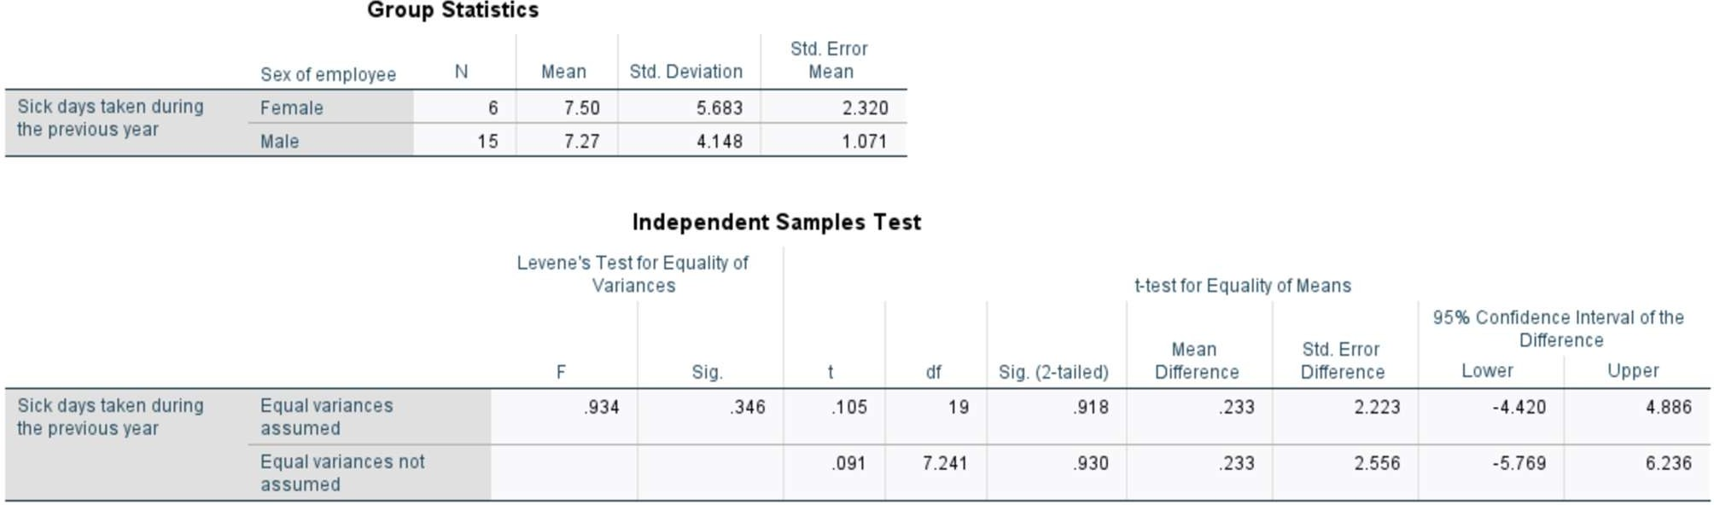
Interpretation: Here t = 0.105, df = 19. Since p-value = 0.918 > 0.05. Hence, we do not reject H0. There is strong evidence to say that there is no significance difference between average number of sick days taken during the previous year by male and female.

- One way ANOVA test:
  - Test the hypothesis that is there any significance difference between mean salary of employees with education level.
Solution: H0: µ1 = µ2 = µ3 = µ4 = µ5
v/s H1: at least one is different

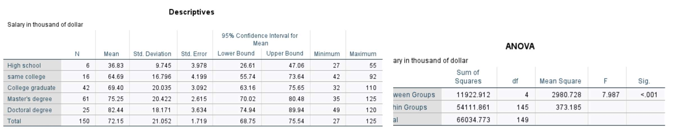

Interpretation: Here, F= 7.987. Since p-value < 0.001 < 0.05. Hence, we reject H0. There is significant evidence that the mean salary differs across education levels.

  - Test the hypothesis that is there any significance difference between value of house with number of bed room in the house.
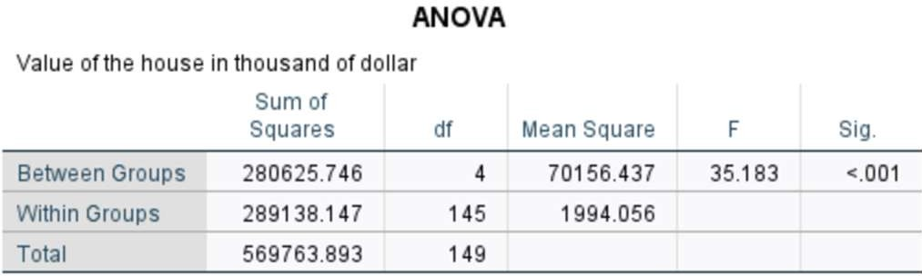
Solution:
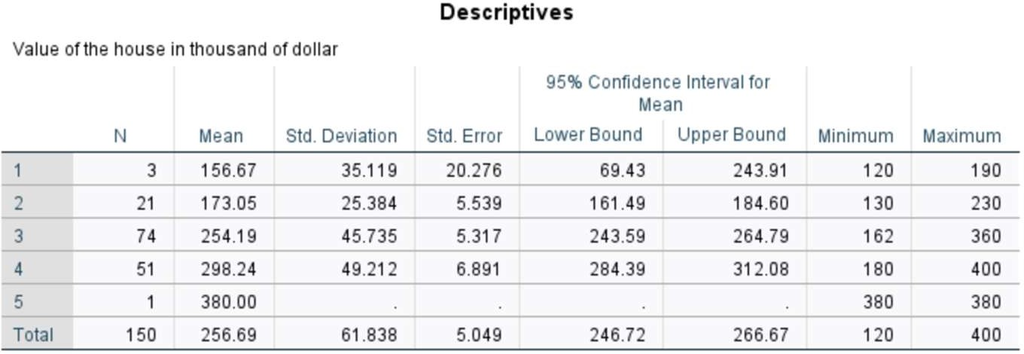

Interpretation: Here, F= 35.183. Since p-value < 0.001 < 0.05. Hence, we do not reject H0. There is significant evidence that the mean house value differs across number of bedrooms.

